Do you think that college should be free ?

By Emery Neyer

I think that college should be free because you need an education for your job. If you do not have an education, your future would not have a big purpose. Most people do not have enough money to get into a good college or get into a college at all. People have been studying for their whole life just to be unfortunate enough to stop their education after high school because of money.

Studies show, free colleges will help decrease student debt. Student loan debt is about 1.75 trillion dollars! 45 million people in America have student loans. Nurses, lawyers, and many other jobs will cause you to stay in school longer which will make you pay more money to the school. This will give you more student loans which are not going to help your life.

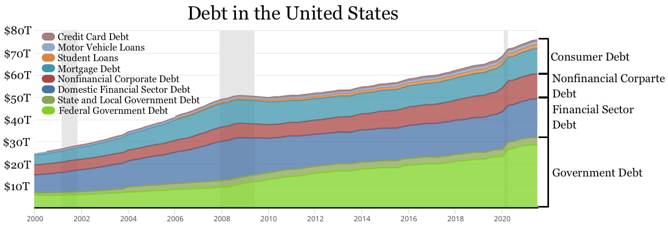

What if you have a lot of student debt? Then when you get your paycheck you have to pay the loans with all the money you worked so hard to earn. This will leave you with very little money to buy food, and not be able to have the stuff you need for your college. This could lead to hard times in the future.

In conclusion, I believe that college should be free so that students have less debt and can enter into any college they want! What do you think? Should college be free?